1. Write a shell script to print the numbers from 1 to 10.

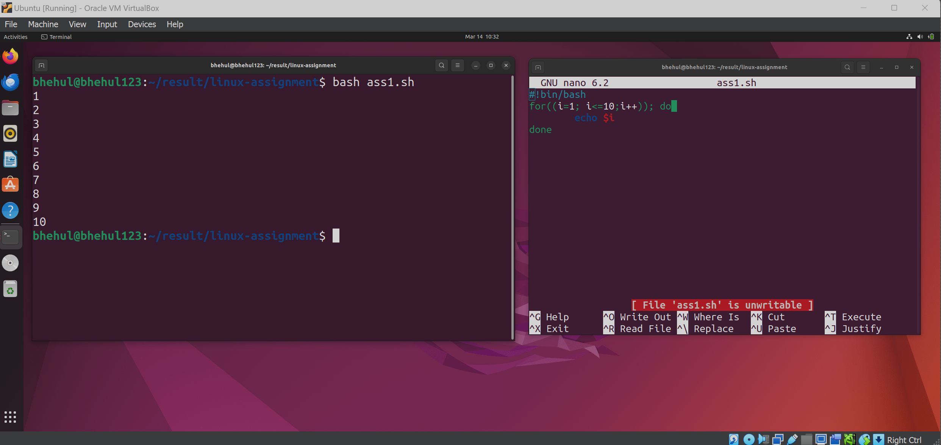

1. Write a shell script to ask the user for their name and print a greeting message.

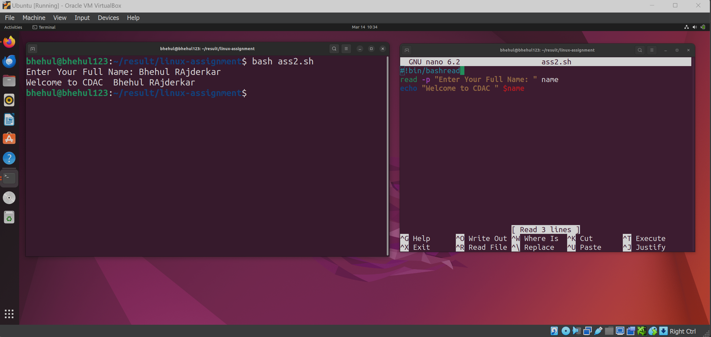

3. Write a shell script to check if a file exists in the current directory and print a message

accordingly.

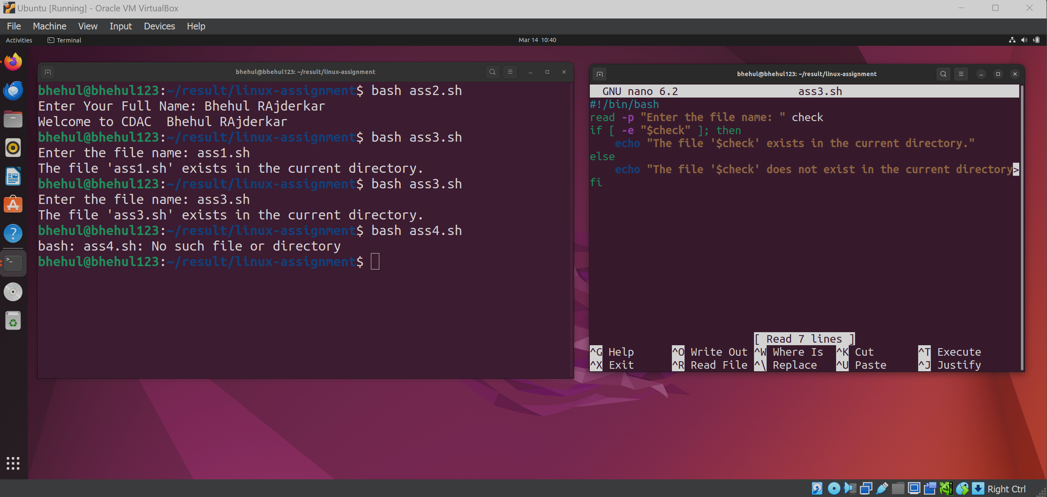

4. Write a shell script to calculate the sum of two numbers the user enters.

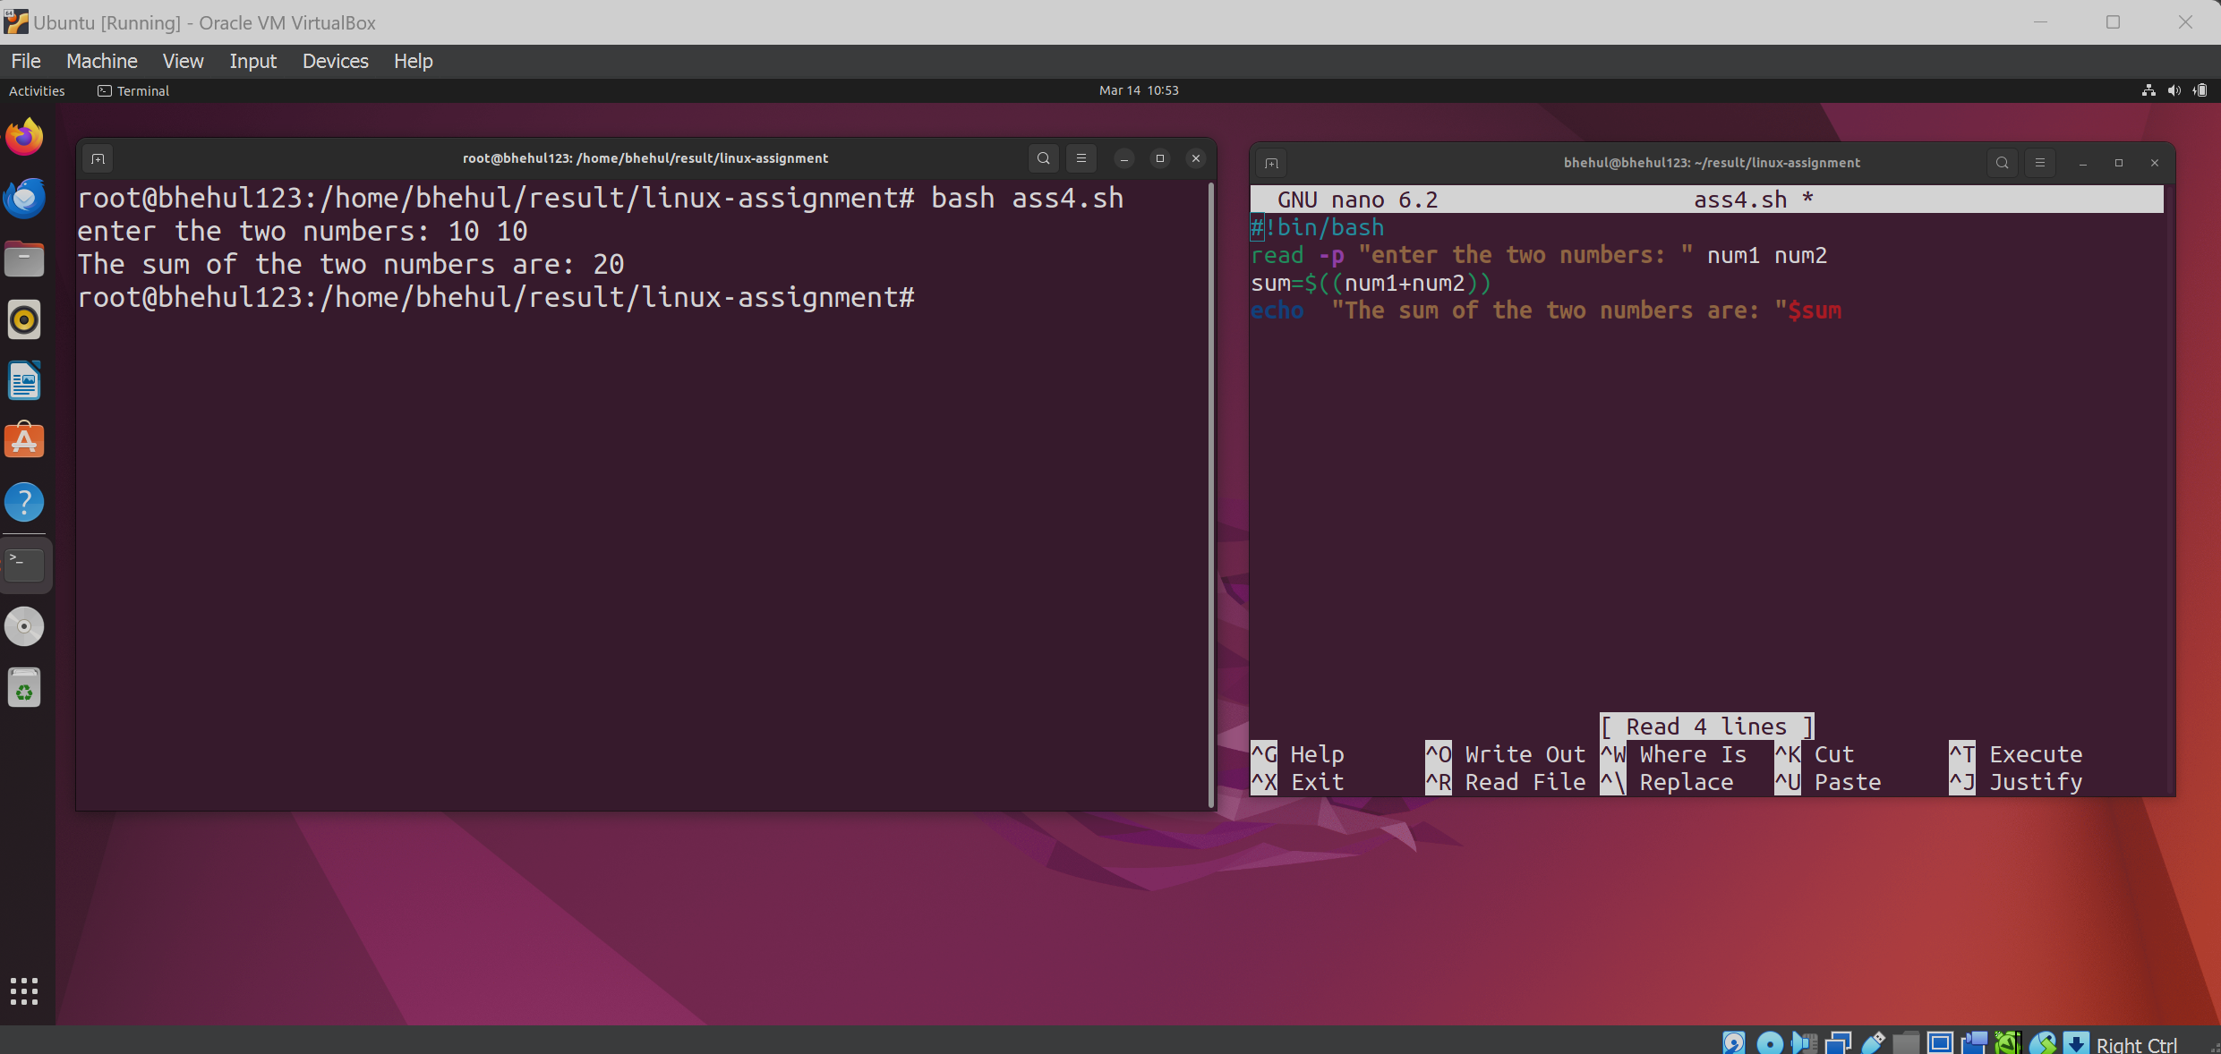

5. Write a shell script to find the largest number among three numbers entered by the user.

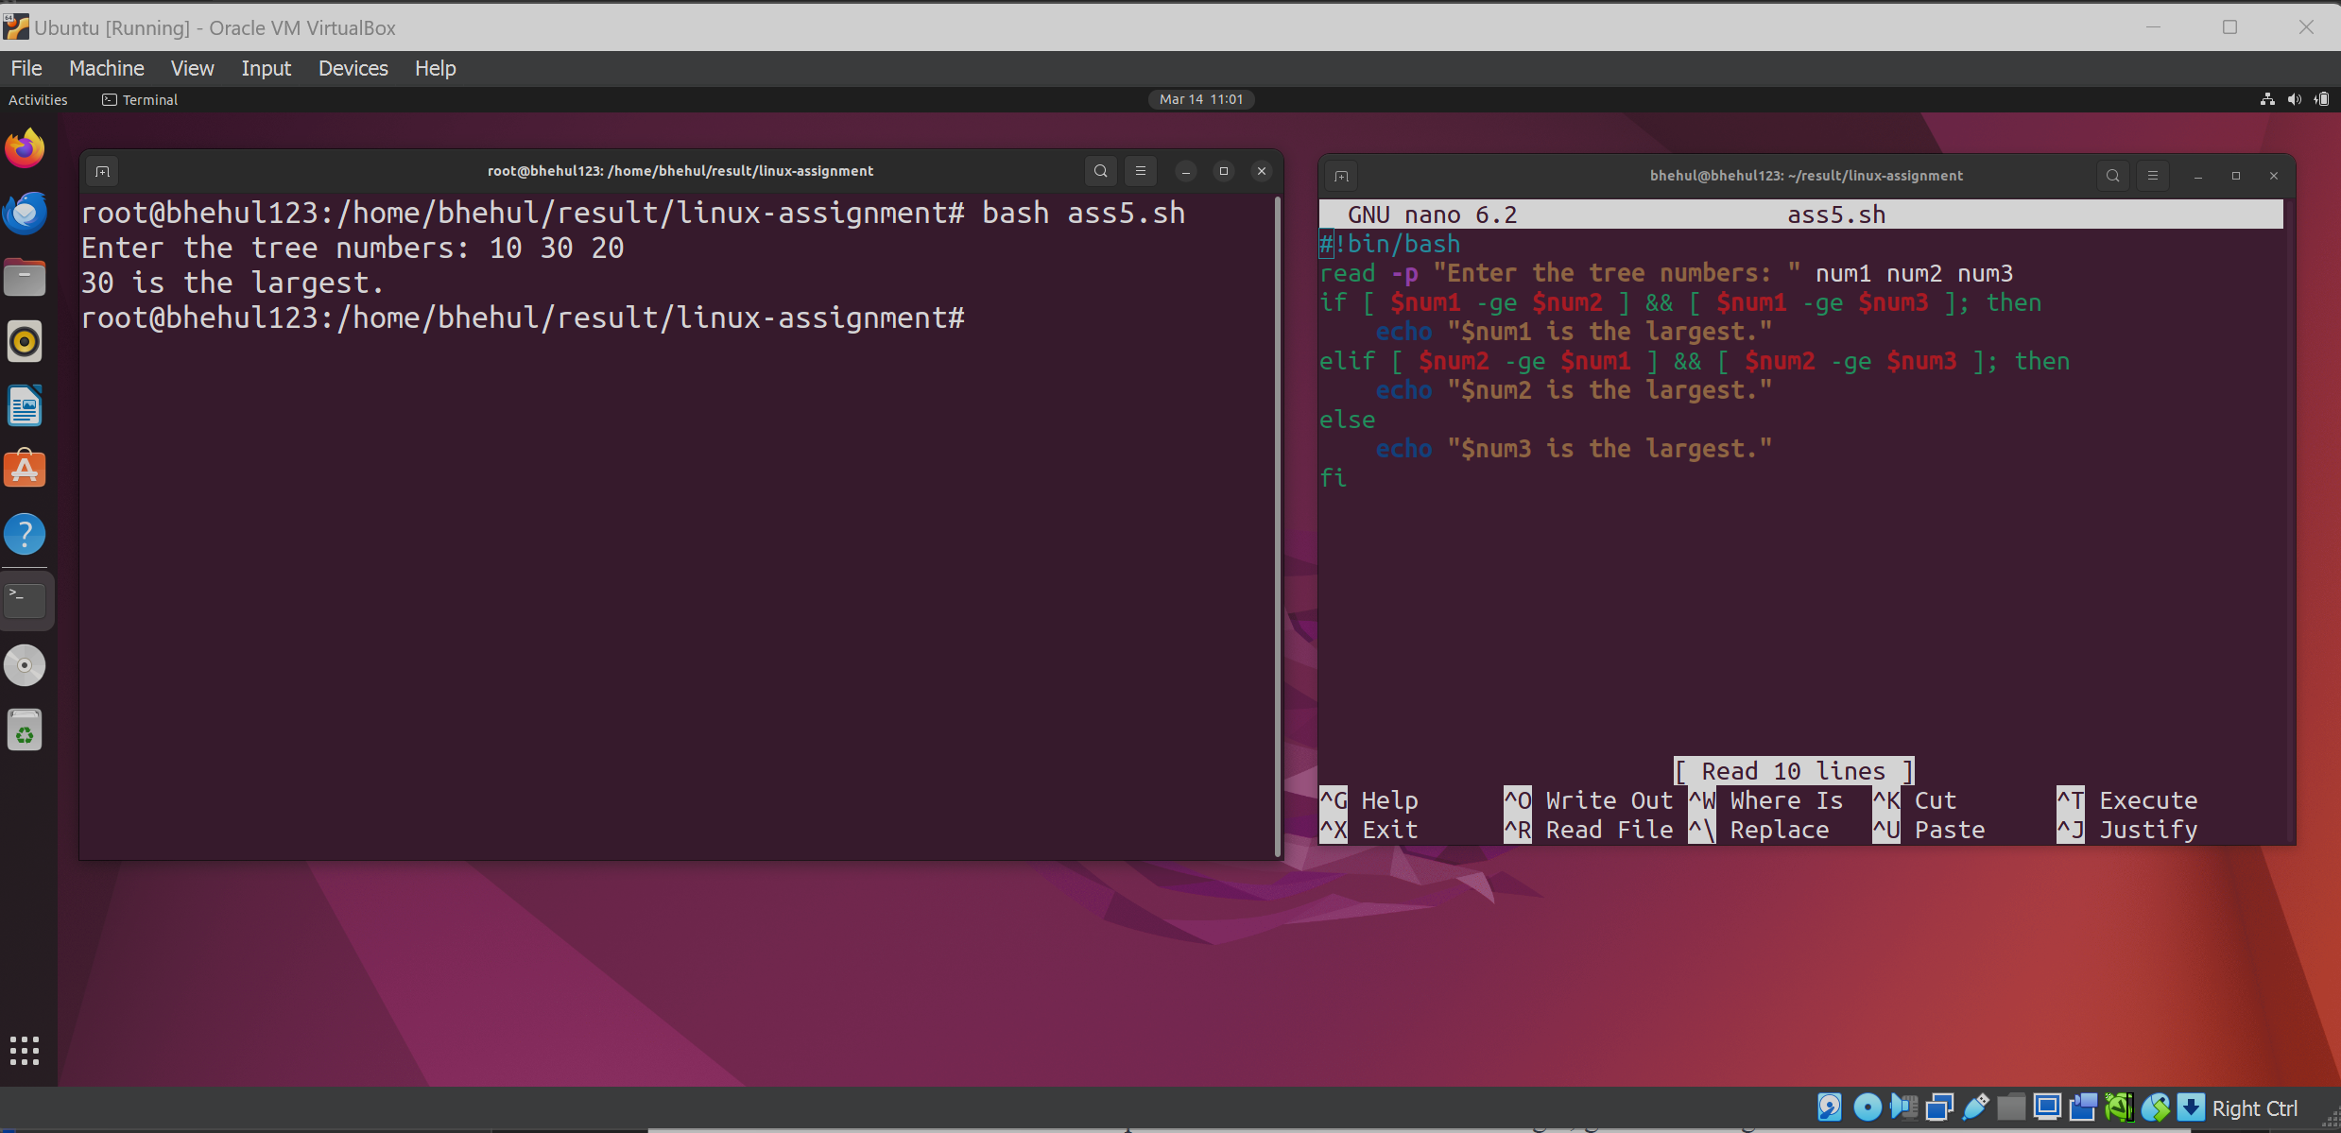

6. Write a shell script to check if a number is odd or even.

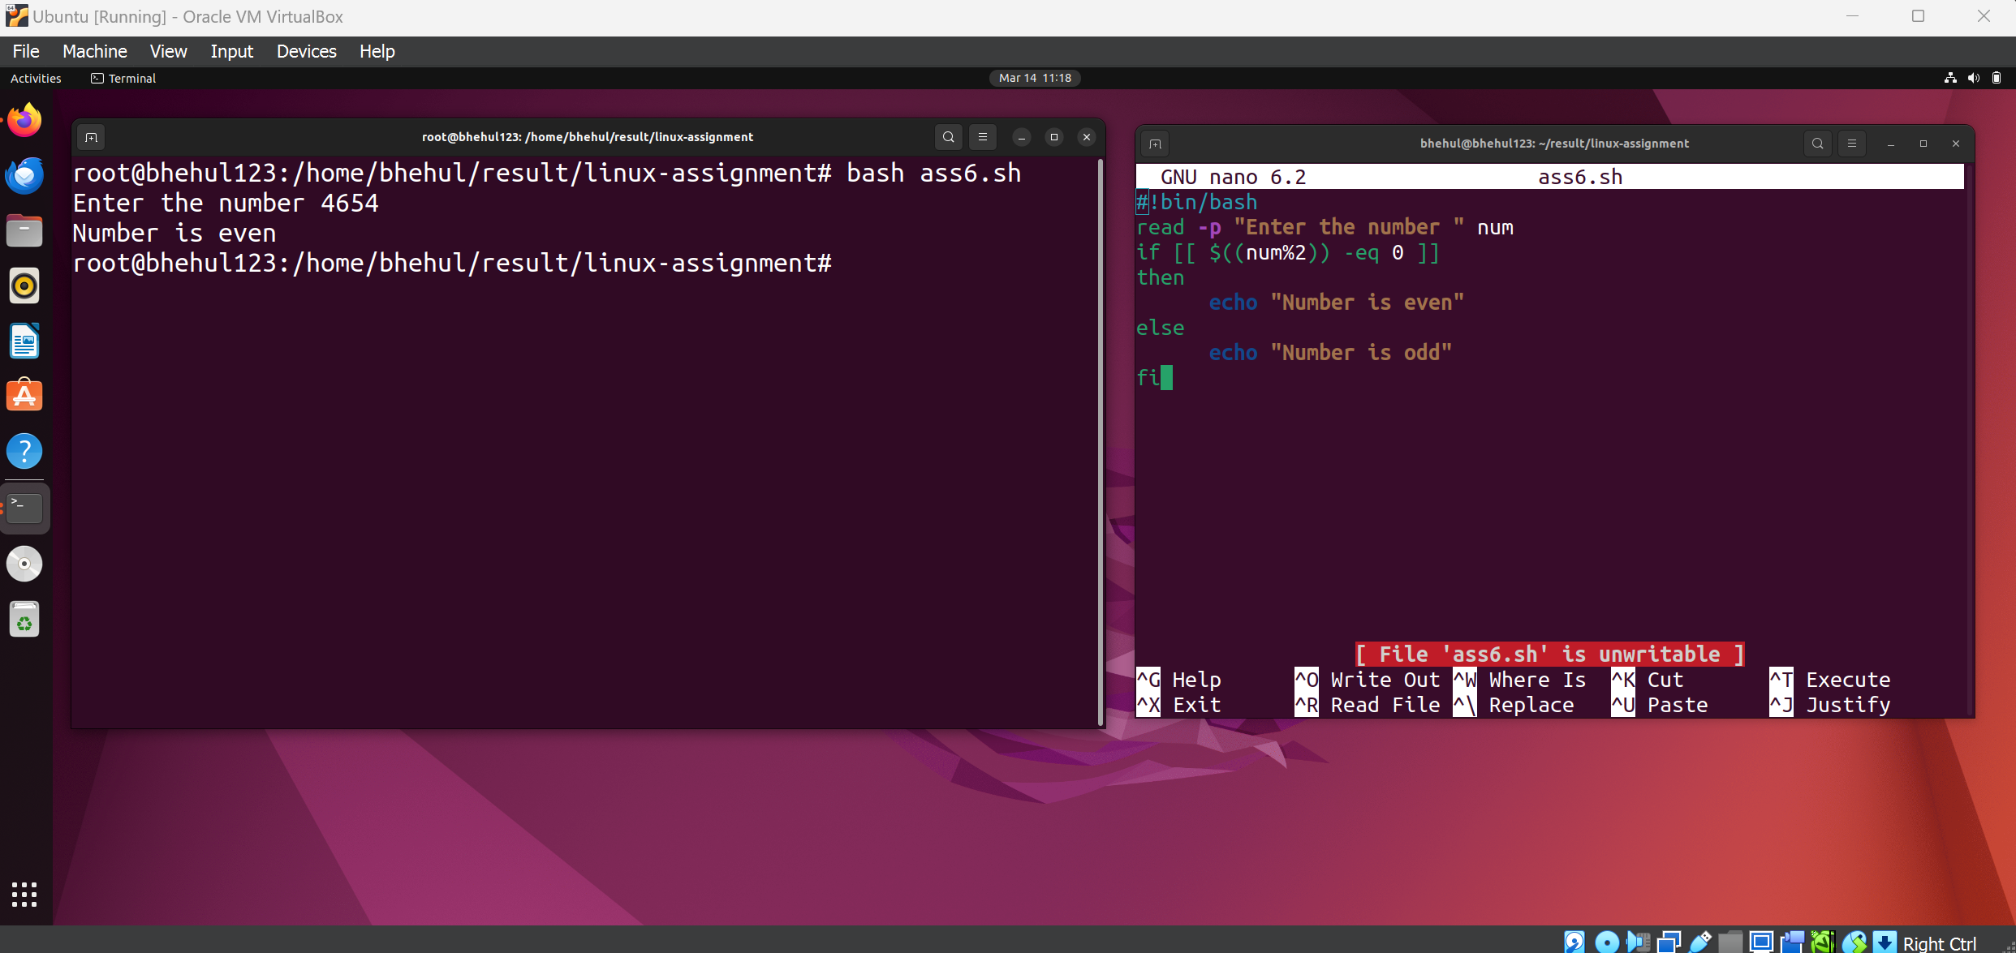

7. Write a shell script to display the contents of a file line by line.

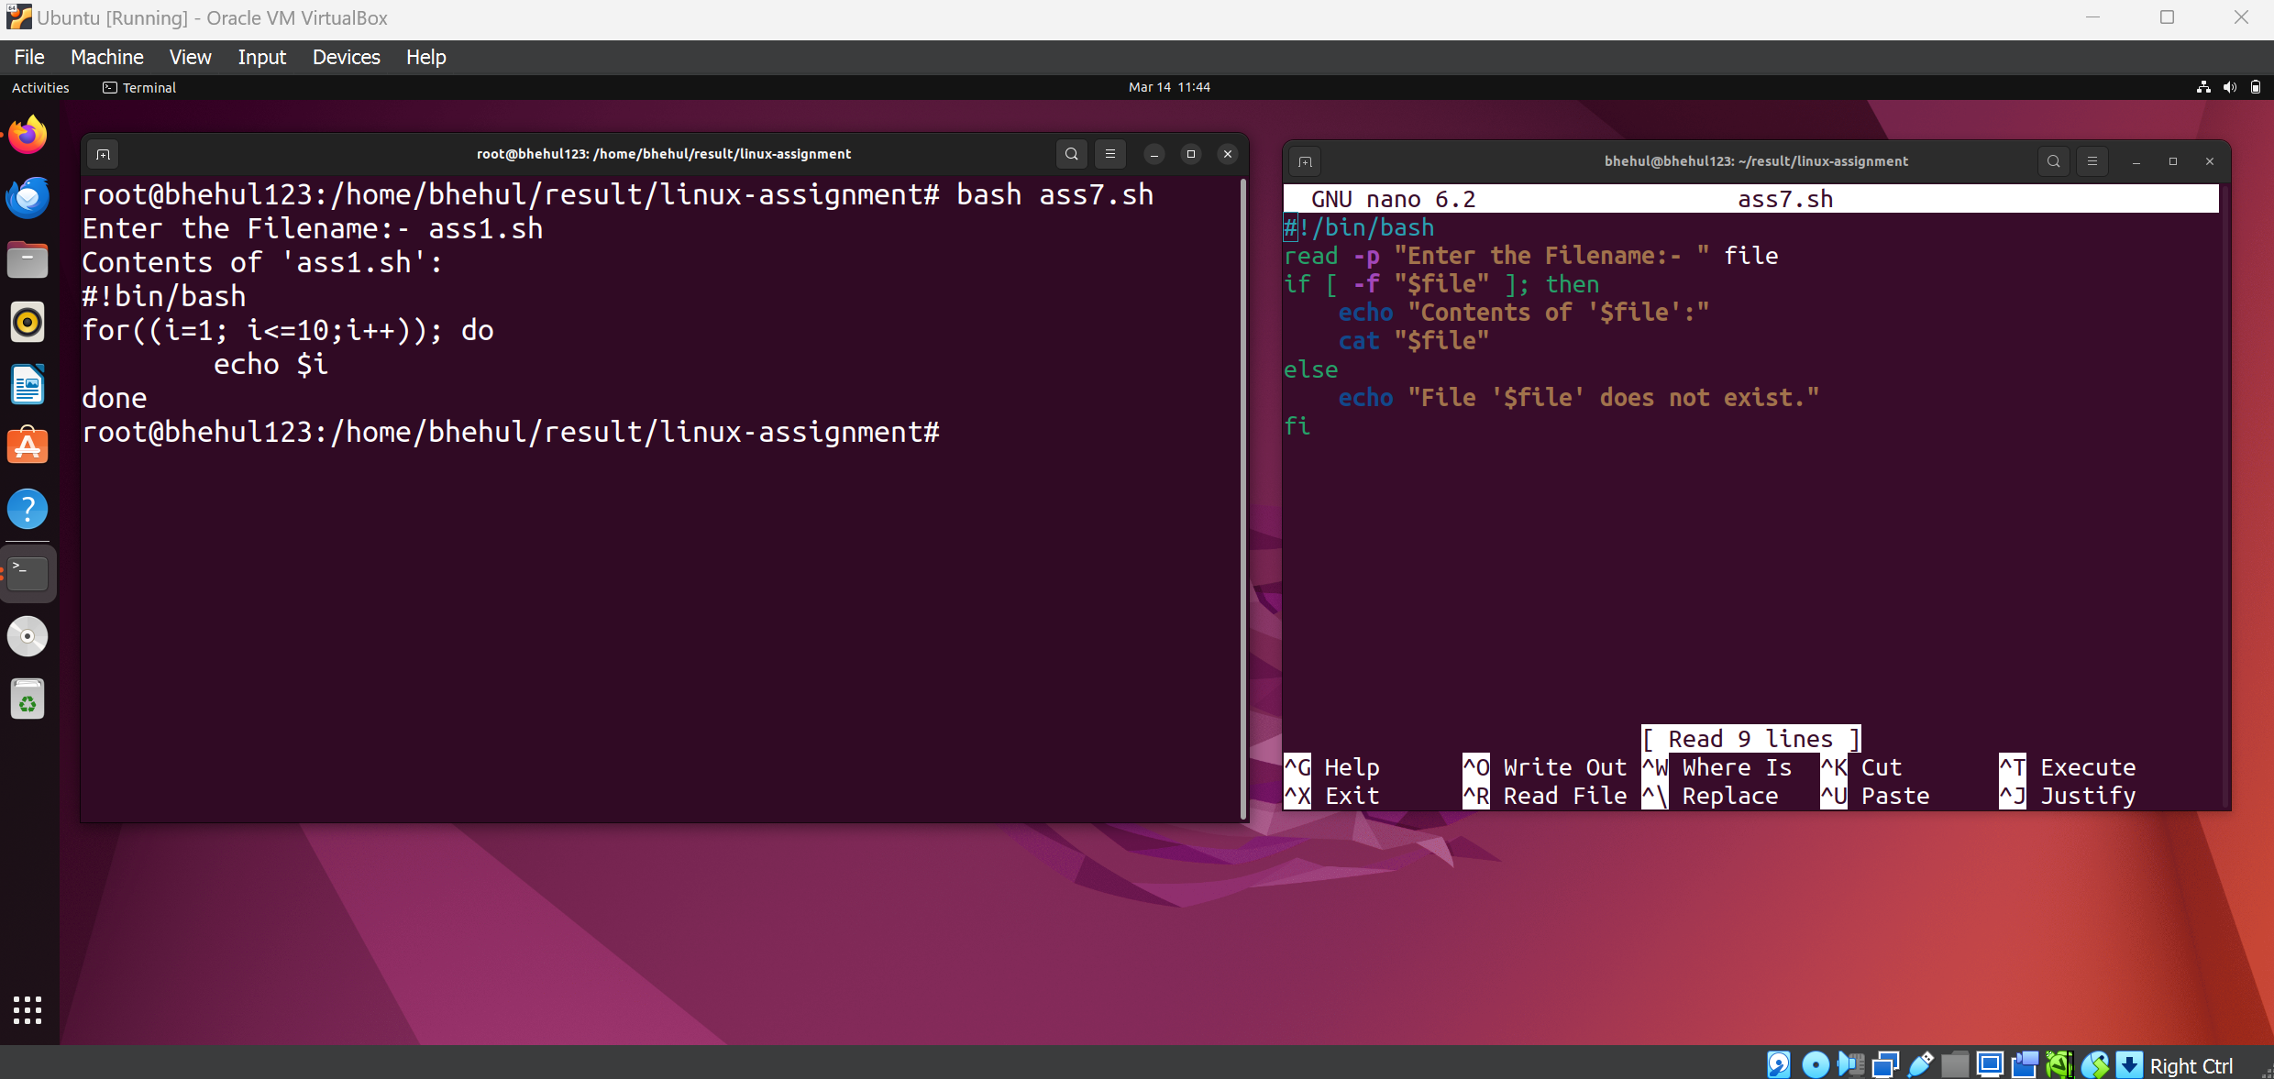

8. Write a shell script to count the number of files in a directory.

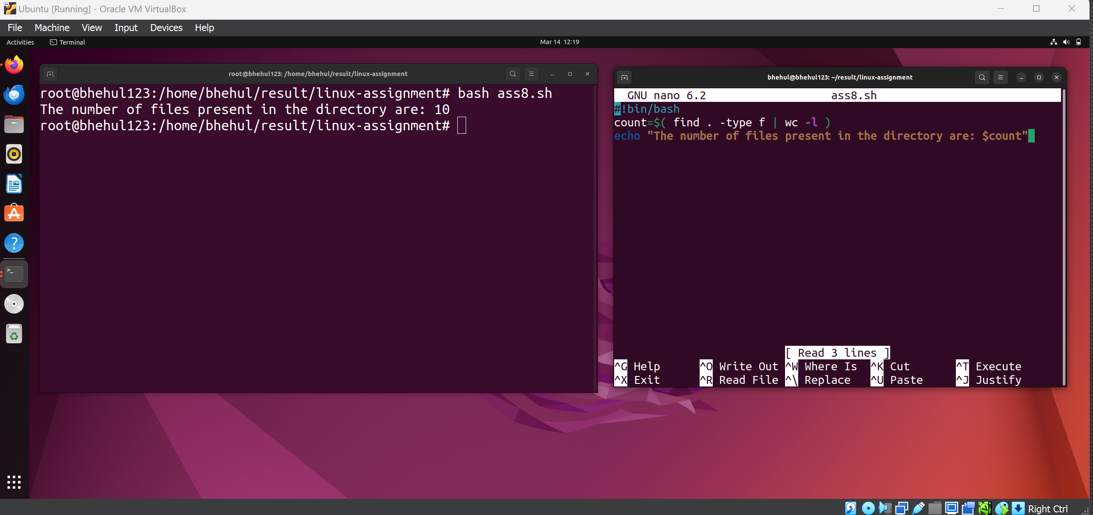

9. Write a shell script to print the current date and time.

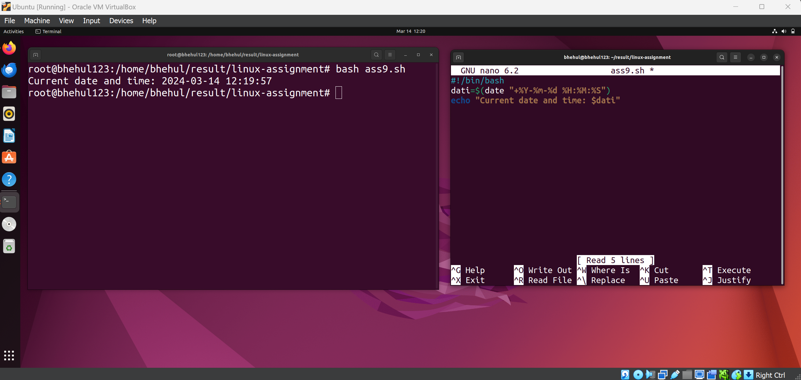

10. Write a shell script to rename all files with a certain extension in a directory.

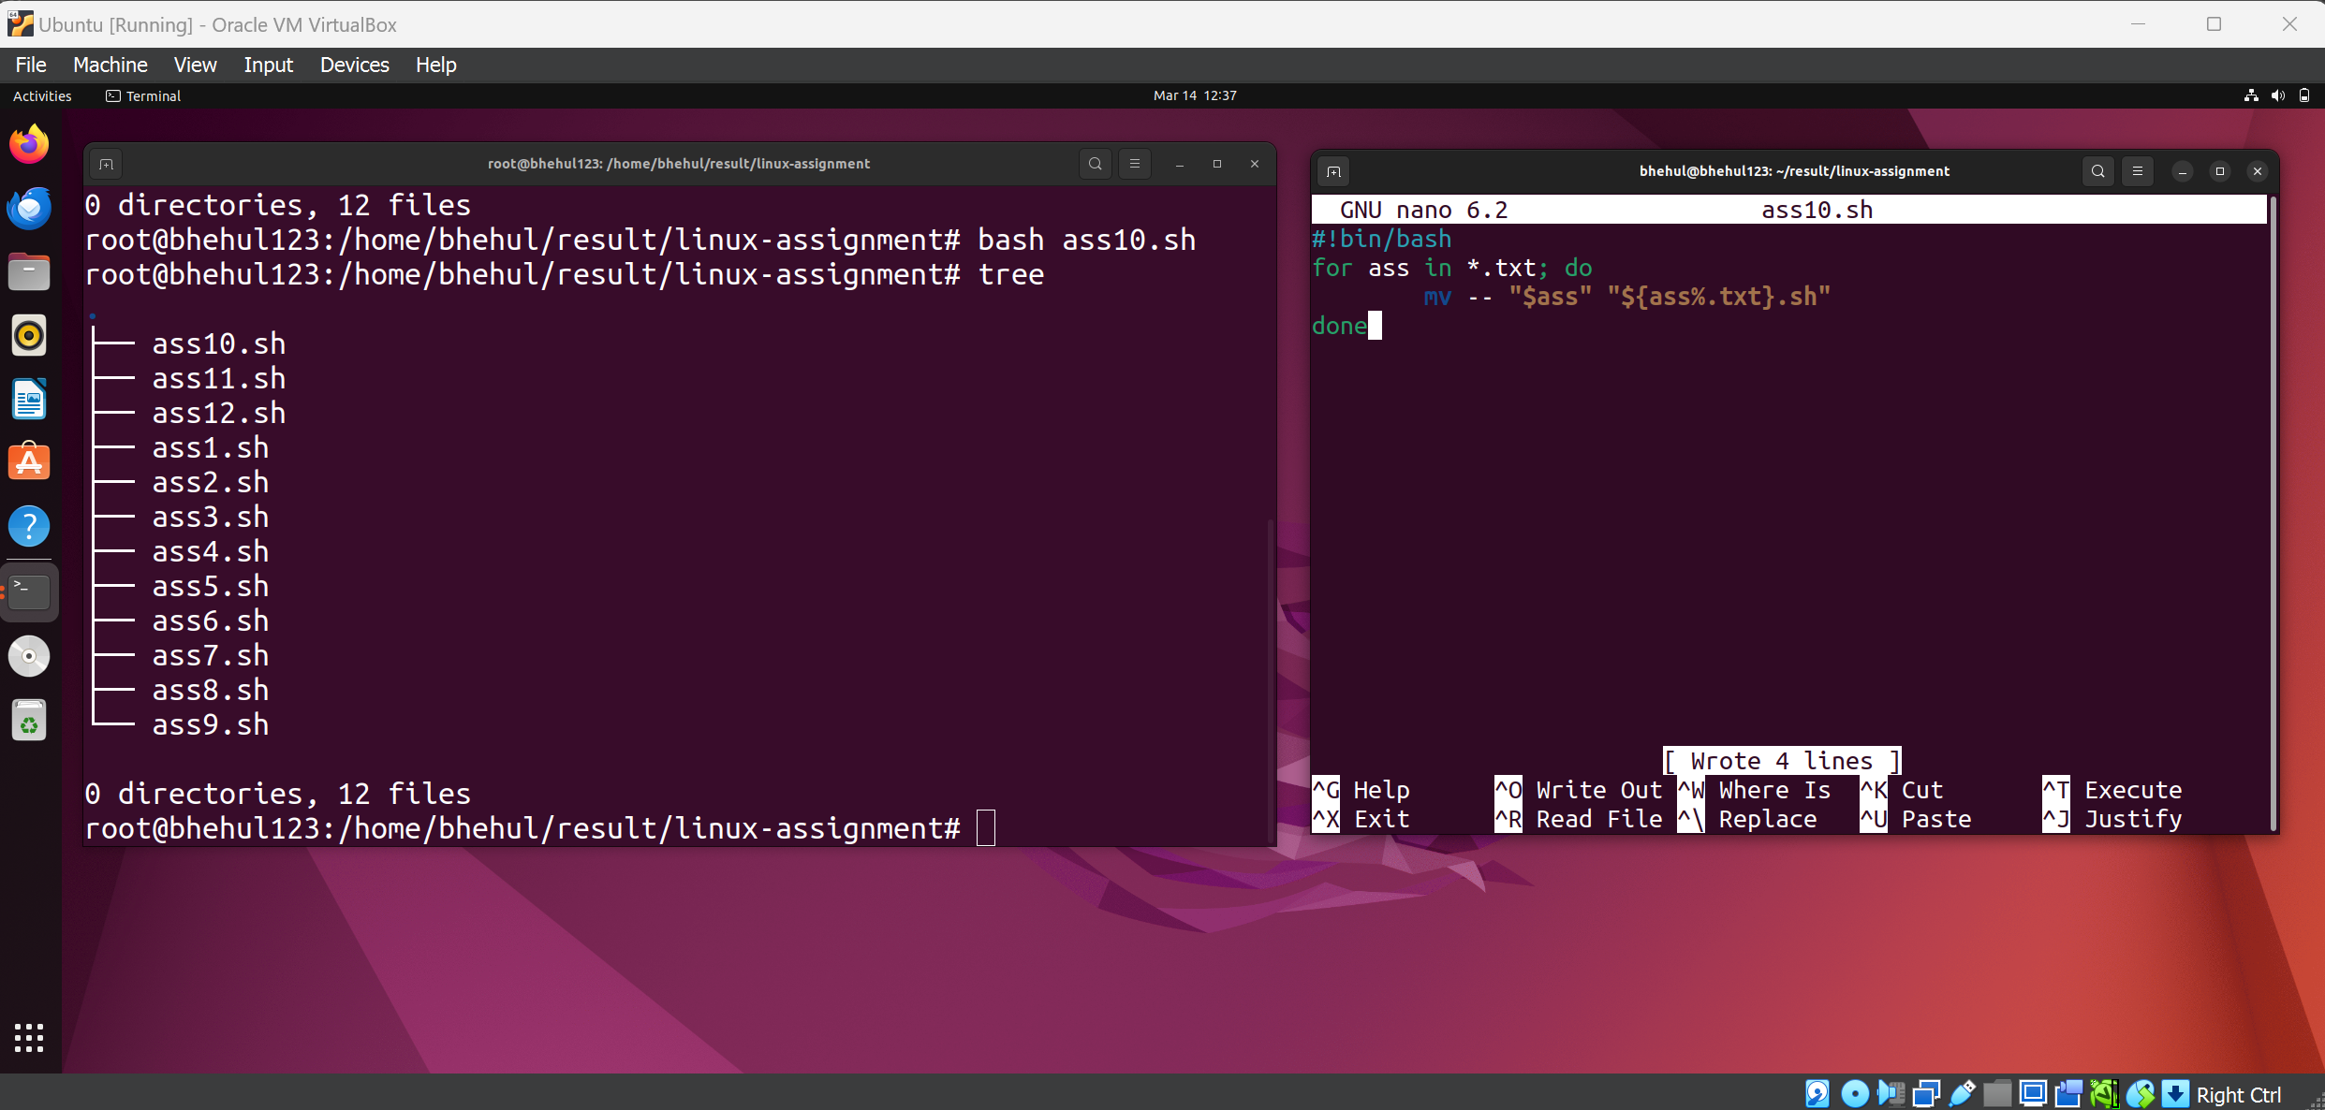

11. Write a shell script to print the even numbers from 1 to 20.

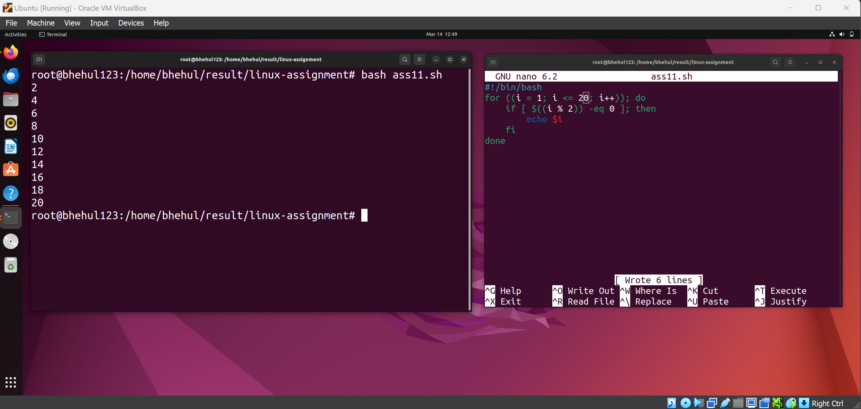

12. Write a shell script to find the factorial of a number entered by the user.

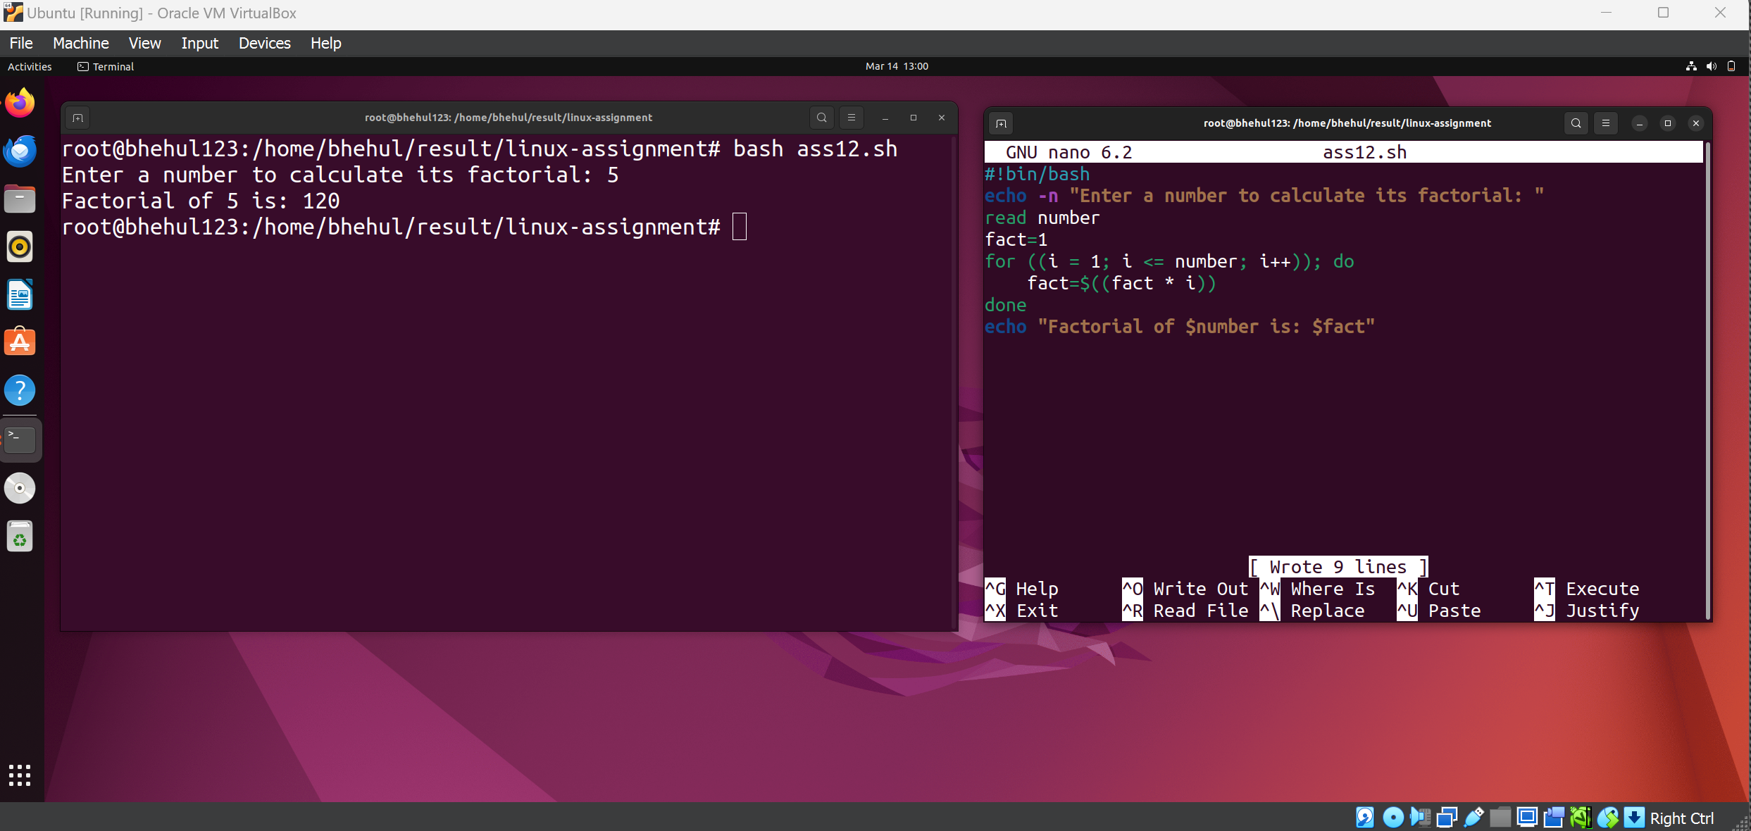

13. Write a shell script to create a backup of a file with a timestamp in the filename.